Project Title: **Let’s Meet**

(By SEMESTER – V of III Year M.Sc. (2017-18))

Group Id: 05

Student Name: Roll No.

1. Jaishil Bhavsar: 2153005
2. Zeel Modi: 2153036
3. Bhargavi Jansari: 2153186

Company Name: Dhruv Corporation

Date of Submission: 16th December, 2017

Submitted to:

logo

K. S. School of Business Management

M.Sc. – Computer Applications and Information Technology

**Acknowledgement**

The success and final outcome of this project required a lot of guidance and assistance from many people and we are extremely fortunate to have got this all for our project work. Whatever we have done is only due to such guidance and assistance and we would not forget to thank them.

We respect and thankful to K.S.S.B.M., for giving us an opportunity to do the project work and providing us all support and guidance which made us completes the project on time. We are extremely grateful to project guide for providing such a nice support and guidance though she had busy schedule.

We would like to express our gratitude towards Course coordinator Department and our project mentor for their kind co-operation and encouragement, which helped us in this project.

Group Id: - 5

Jaishil Bhavsar (3005) Zeel Modi (3036)

Bhargavi Jansari (3186)

Index

Chapter 1: Introduction

1.1 Organization Profile6

1.2 System Details7

1.2.1 Existing System8

1.2.2 Proposed System8

1.3 Scope of System9

1.4 Objectives10

Chapter 2: Proposed System Requirement Gathering

2.1 Stakeholder of System11

2.2 Requirements Gathering Technique Used12

2.3 Consolidated List of Requirements19

2.4 Project Definition20

Chapter 3: System Management and Planning

3.1 Feasibility Study21

3.1.1 Technical21

3.1.2 Economical21

3.1.3 Operational22

3.2 Hardware – Software Requirements23

3.3 System Planning24

3.3.1 Work Breakdown Structure24

3.3.2 Gantt Chart25

3.4 Process Model26

Chapter 4: System Analysis and Design

4.1 [UML [Unified Modeling Language]](#_[4.1]_UML_(Unified)28

4.2 System Flow Diagram35

4.3 Data Dictionary36

4.4 User Interface40

4.5 System Navigation53

Chapter 5: Summary

5.1 Assumptions54

5.2 Limitations54

5.3 Conclusions54

5.4 Future Scope54

Bibliography55

# **Chapter 1: Introduction**

**Let’s Meet** helps people do more of what they love by finding and creating communities based around the ideas and activities that matter to them. Meetups are formed around a common interest, goal, or cause, and they are made up of regular, face-to-face gatherings.  
  
Meetups help people:

* Do what they love
* Find others and make friends
* Get involved in local communities
* Learn, teach, and share
* Rise up, stand up, unite, and make a difference
* Be part of something bigger – both locally and globally

# [**1.1**] Organization Profile

▪ Organization Name:

Dhruv Corporation.

▪ Address:

23, RadhaKrishna Avenue, Opp. Golden Triangle, Stadium Road, Navrangpura, Ahmedabad-18, Gujarat, India.

▪ Contact No.: 9428106009

▪ Name and the Designation of Chief Functionary:

➢ Name: Mr. Arvind Modi

➢ Designation: Owner

▪ About Organisation:

Dhruv Corporation is a Fabric Trading Company which provides different types of fabric. The Company’s owner is Mr. Arvind Modi. He has been running from last 3 years. It has started from 2014. It has started from a little cabin to a big castle. First shop of Dhruv Corporation was in Ahmedabad where the company got all customers.

The company is having a block printers, embroidering artist and even a Kalamkari artist which provides all types of varieties on Fabrics. Company is getting its growth. They are taking customer orders and they also organise Fashion shows every year to advertise and market their different products.

They are serving their Fabric to most of all boutique in Ahmedabad and even out of town. Company is organising a little concept about gathering people and connect them. Company has planned to create events which are on one platform. It is organised around one simple idea “When we get together and do the things that matter to us we are at our best!” Their motto is the connecting bridge between user who are looking for events and event promoters who are in search of their audience.

# [**1.2**] System Details

Project Title : - **Let’s Meet**

Team Size : - **3**

Developers : - **Jaishil Bhavsar**

**Zeel Modi**

**Bhargavi Jansari**

Time Duration : - **6 Months**

Basic

Requirements : - **Android/iOS Device**

**Desktop/ Laptop**

**Internet Connection**

# [**1.2.1**] Existing System

There is no Current System. The system is working manually. The current system is time consuming because it involves a lot of paperwork and efforts.

In manual system they are calling people and informing them about the event that is about to happen. Sometimes while calling everyone is not reachable at the moment.

It will take more time and this whole procedure is very tedious and takes a lot of time.

The existing system is not as much user friendly compared to our proposed system. So people demand such a system that reduces their time and attend events easily.

# [**1.2.2**] Proposed System

Our System provides a common platform to people to do more of what they want to do in life. It is organized around one simple idea: “when we get together and do the things that matter to us, we’re at our best.” And that’s what our system does. It brings people together to do, explore, teach and learn the things that help them come alive.

# [**1.3**] Scope of System

* Event *recommendations* based on user’s interests
* Users can get the information by following *Communities* as well as more knowledge about their field.
* Speakers and attendees can *exchange* their ideas.
* Users can get to know about seminars, webinars and *events* to be organised *nearby*.
* User can follow the *community*(groups e.g. Java, management, book clubs, adventures)
* User will be *notified* about the events via Notification and E-mails.
* *Discover* popular and recommended events near you
* Find *upcoming* events and things you want to do nearby today, this week, this weekend, or any time
* See which events your *friends* are *attending*
* Easily *share* events with your friends via WhatsApp, Hike , E-mail, Twitter, Facebook
* Post Group *polls*
* Attendees can also give their feedback and reviews about event
* User can post *stories* about what’s happening around
* *Key notes* regarding to past events

# [**1.4**] Objectives

* Openness to know about people in the same field
* Broader Network Opportunities
* People can learn new things
* A space where everyone can know what is happening around.
* We are the connecting bridge between users who are looking for events and event promoters who are in search of their audience.

# [**2.1**] Stakeholder of System

Stakeholders can be defined as “anyone who has an interest in system to be built”. Stakeholders may include individuals and groups of people who have some direct interest in the event’s planning, production and implementation or in participating in. Following are the Stakeholders of our System:

* Admin
* Event Organiser
* Participants
* Community
* User

1. Admin:
   * Admin is a person who is responsible for verifying and validating the events that are going to happen.
   * He or she manages meet the needs of the user.
2. Event Organiser:

* He is the person who organises the event to provide people of his interest to know more about their field.

1. Participants:

* Participants can be speakers, attendees, fans, visitors who attend event to explore something.
* Without the present of participant an event is impossible so there must be participants to attend an event.

1. Community :

* Local community includes indigenous people, NGOs, network, environmental groups.
* Here user can discuss also about problems.

1. User :

* The main objective of the system is to provide information of nearby events to the user so that all the events are placed on a single platform and doesn’t have to waste time in search of events on another platforms.
* A user is a person who makes bond with the system and take benefits provided by the system.
* User can give feedback for the system.

# [2.2] Requirement Gathering Technique Used

Requirements elicitation is the process to find out the requirements for a proposed system by communicating with end-users, client, system-users and other who have a stake in the system development.

There are various ways to discover requirements:

1. Interviews :

* Interviews are strong medium to collect requirements. Organizations may conduct several types of interviews such as:
  + Structured(closed) Interviews
  + Non-structured(open) Interviews
  + Oral Interviews
  + Written Interviews
  + One-to-one Interviews
  + Group Interviews

1. Surveys :

* Organizations may conduct surveys among various stakeholders by querying about their expectation and requirements from the upcoming system.

1. Questionnaires :

* A document with pre-defined set of objectives questions and respective options is handed over to all stakeholder to answer, which are collected and then compiled.
* A shortcoming of this technique is, if an option for some issue is not mentioned in the questionnaire, the issue might be left unattended.

1. Task Analysis :

* Team of engineers and developers may analyse the operation for which the new system is required. If the client already has some software to perform certain operation, it is studied and requirements of proposed system are collected.

1. Domain Analysis :

* Every software falls into some domain category. The expert people in the domain can be a great help to analyse general and specific requirements.

1. Brainstorming :
   * An informal debate is held among various stakeholders and all their inputs are recorded for further requirements analysis.
2. Prototyping :
   * Prototyping is building user interface without adding detail functionality for user to interpret the features of intended software product. It helps giving better idea of requirements.
   * The prototype is shown to the client and the feedback is noted. The client feedback serves as an input for requirement gathering.
3. Observation :
   * Team of experts visit the client’s organization or workplace. They observe the actual working of the existing installed systems. They observe the workflow at client’s end and how execution problems are dealt.
   * The team itself draws some conclusions which aid to form requirements expected from the software.

For our system we have used Questionnaire so that we can have wide range of idea of the needs of our stakeholders.

We have given different Questionnaires to different stakeholders. We want to know what they need in proposed system.

For the Users the following Questionnaire form is prepared:

1. Do you regularly like attending Webinars, Seminars, Work-shops, Book Launches, etc.?
   * Yes
   * Sometimes
   * No

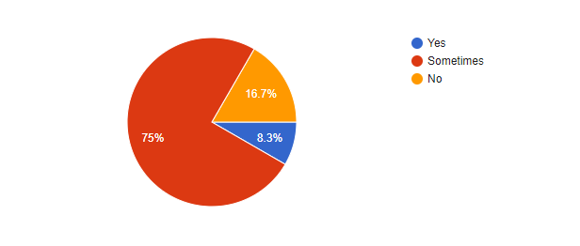

1. Are you using any system to get notified about events? If yes, then which is it?
   * Yes. Please specify_____________________
   * No

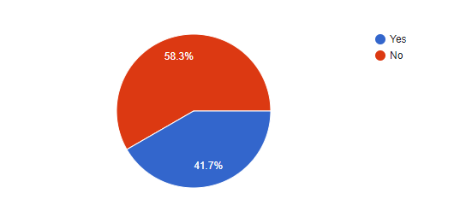

1. How would you like to get registered to our website?
   * Social Media
   * Manual Signup

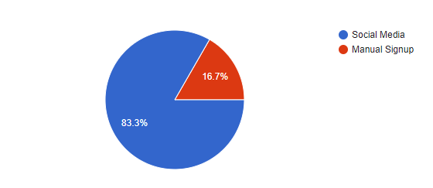

1. How would you like to be notified about events?
   * E-mail
   * System Notification
   * SMS

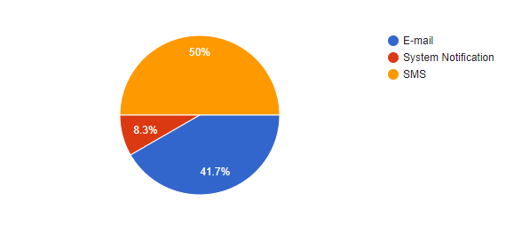

1. Which configuration method you prefer?
   * SMS
   * E-mail

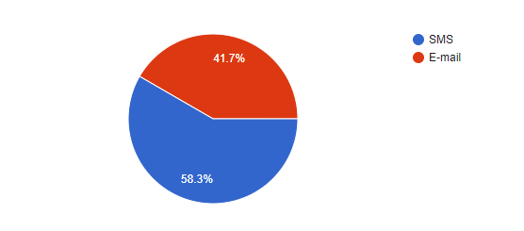

1. Do you know any event agencies? If yes then please specify.
   * Yes. Please specify_____________
   * No

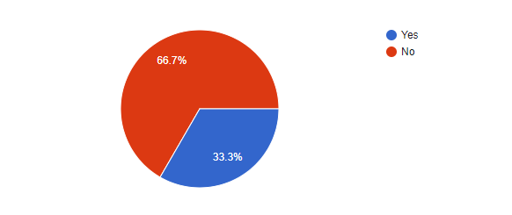

1. Would you like to use our services in future regarding events?
   * Yes definitely
   * Not at all. Please specify_____________

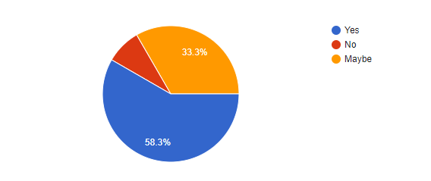

For the Event Organisers the following Questionnaire form is prepared:

1. Normally how you promotes your events?
   * Radio
   * Social Networking
   * Roadside Banners
   * Newspapers
   * Application

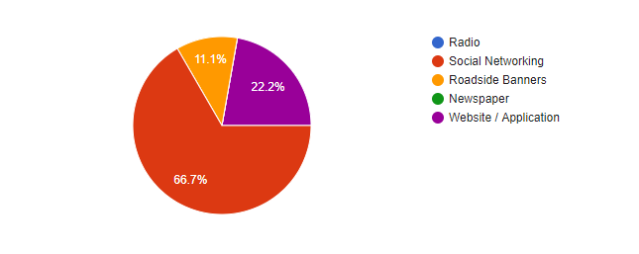

1. What kind of audience are you expecting?
   * Professional
   * Student
   * Others. Please Specify_____________

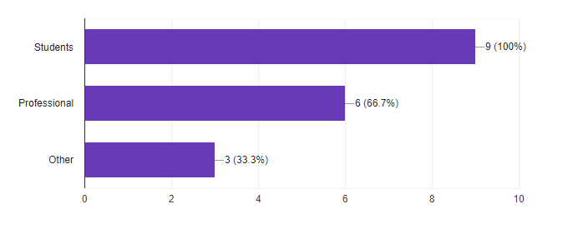

1. Do you get a good amount of audience for your event?
   * Yes
   * Average
   * Poor
   * No

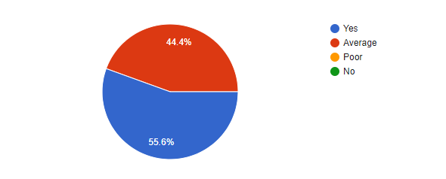

1. Will there be tickets for events?
   * Yes
   * No

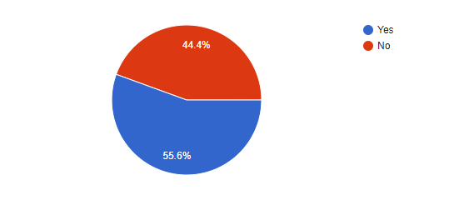

1. Do you take feedback for your events?
   * Yes
   * No

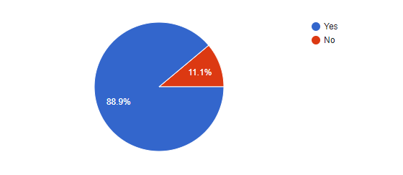

1. Would you like to promote your events by our system?
   * Yes
   * Maybe
   * No. Please specify reason___________

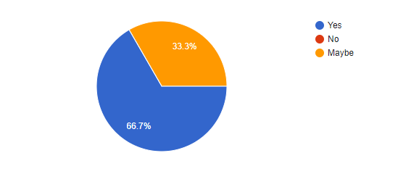

# [2.3] Consolidated List of Requirement

By taking Questionnaire we have decided to make following change in our system:

**Users:**

* Users need to login from Social Media rather than manual Signup, which saves their time and effort for remaining passwords.
* They wants to be notified by application notifications,
* They prefer SMS authentication over E-mails.
* They need all the types of event happening in city on a single platform.

**Event Organisers:**

* Organisers need a platform where they can attract a good amount of audience for their events.
* They need a feedback about their event so that they can improve it in future.

# [2.4] Project Definition

Hundreds of events happens in our city, but it’s difficult to find them out. ‘Let’s Meet’ helps you do that..!!Our System provides a common platform to people to do more of what they want to do in life. It is organized around one simple idea: “when we get together and do the things that matter to us, we’re at our best.” And that’s what our system does. It brings people together to do, explore, teach and learn the things that help them come alive.

# [**3.1**] Feasibility Study

A feasibility study is carried out to select the best system that meets performance requirements.

The main aim of the feasibility study activity is to determine whether it would be financially and technically feasible to develop the product. The feasibility study activity involves the analysis of the problem and collection of all relevant information relating to the product such as the different data items which would be input to the system, the processing required to be carried out on these data, the output data required to be produced by the system as well as various constraints on the behaviour of the system.

## [3.1.1] Technical Feasibility:

This is concerned with specifying the equipments and the software to satisfy the user requirements. The technical needs of the system vary considerably but might include:

The facility to produce outputs in a given time.

Response time under certain conditions.

Ability to process a certain volume of transactions at a specified speed.

Facility to communicate data to a distant location.

Technical feasibility centres on the existing computer system, hardware, software etcetera and to what extent it can support the system. In examining the technical feasibility, the configuration of the system is given more importance than the actual hardware.

Our system can be run on any mobile platform including Android, iOS and Windows. So that we can easily say that our system is technically feasible.

## [3.1.2] Economic Feasibility:

Economic analysis is the most frequently used technique for evaluating the effectiveness of a proposed system. More commonly known as Cost / Benefit analysis, the procedure is to determine the benefits and savings that are expected from a proposed system and compare them with costs. The system is economical feasible because:

There is no extra economical cost because system is develop with an open source technology.

Our system is not much costly to develop.

Organisation is ready to invest in proposed system because it is being developed in latest technology.

## [3.1.3] Operational Feasibility:

Operational feasibility study tests the operational scope of the software to be developed. The proposed software must have high operational feasibility. The usability will be high.

Operation of the proposed system depend on its various users.

Various user-types of Users are mentioned below:

1. **Admin:**

Admin will authenticate events and users. If any of these are invalid admin have rights to remove them from using system. Admin can make any change at a time.

1. **Normal User:**

Users will be able to do sign-up, login, feedback any event. Interface of the system is so easy that users don’t have to go anywhere for training.

# [3.2] Hardware – Software Requirement

## Hardware Requirements:

## Software Requirements**:**

# [3.3] System Planning

# [**3.3.1**] Work Breakdown Structure

# [**3.3.2**] Gantt Chart

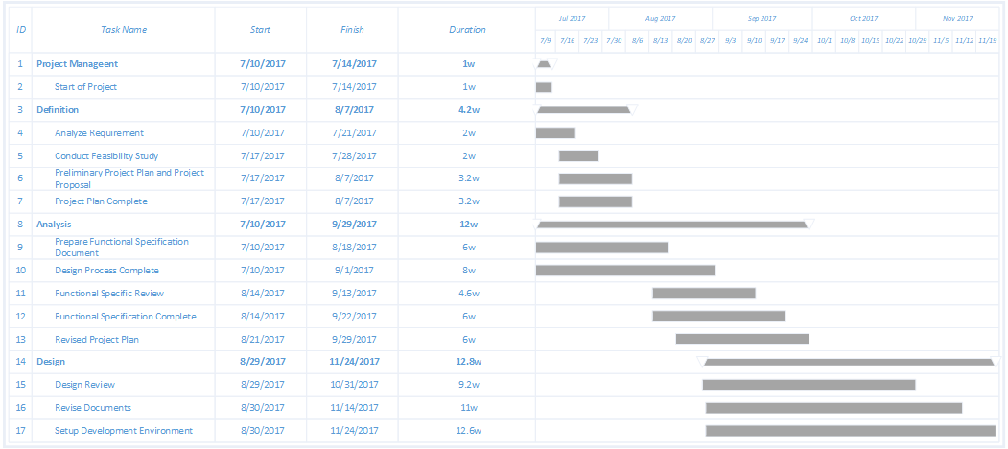

# [3.4] Process Model

A software process model is a standardised format for

• planning

• organising, and

• running

a development project. A software life cycle model is either a descriptive or prescriptive characterization of how software is or should be developed.

**What is Agile Model?**

The Agile methodology (it’s actually a movement, not a methodology) is essentially a list of principles that advocates self-organizing teams, adaptive planning, early delivery, and continuous improvement.

Agile methodologies focus on iterations in which planning, design, implementation and testing occur in short periods of time. Agile methodology allows planning to occur throughout the project lifecycle, thus allowing decisions to be reactive. In software development, bugs can be caught early and remediated before they grow to become bigger problems.

Here’s the agile process for a generic project:

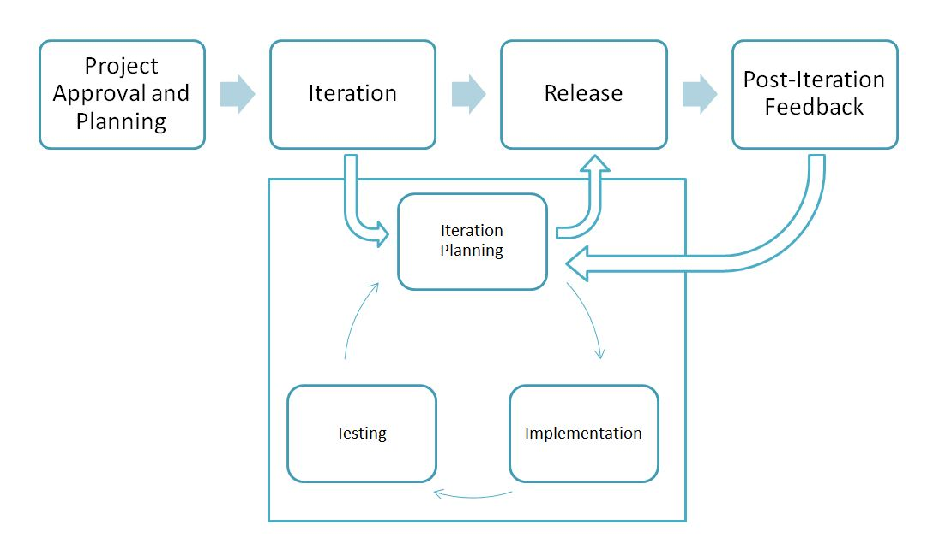

The agile software development emphasizes on four core values.

1. Individual and team interactions over processes and tools
2. Working software over comprehensive documentation
3. Customer collaboration over contract negotiation
4. Responding to change over following a plan

Agile method proposes incremental and iterative approach to software design.

**Why to Use Incremental Model?**

* It is flexible and less costly to change scope and requirements.
* Generates working software quickly and early during the software life cycle.
* We can get our customer responded and can change according to their requirements. Rather than other model here customers have exact idea about their proposed system. In other models customers get their system at last so we can’t know whether our customer is satisfied or not. Here we’re constantly in touch with customer. This model provides higher customer satisfaction.
* Error can be fixed in the middle of the project.

# [**4.1**] UML (Unified Modeling Language)

# [**4.4.1**] Use Case

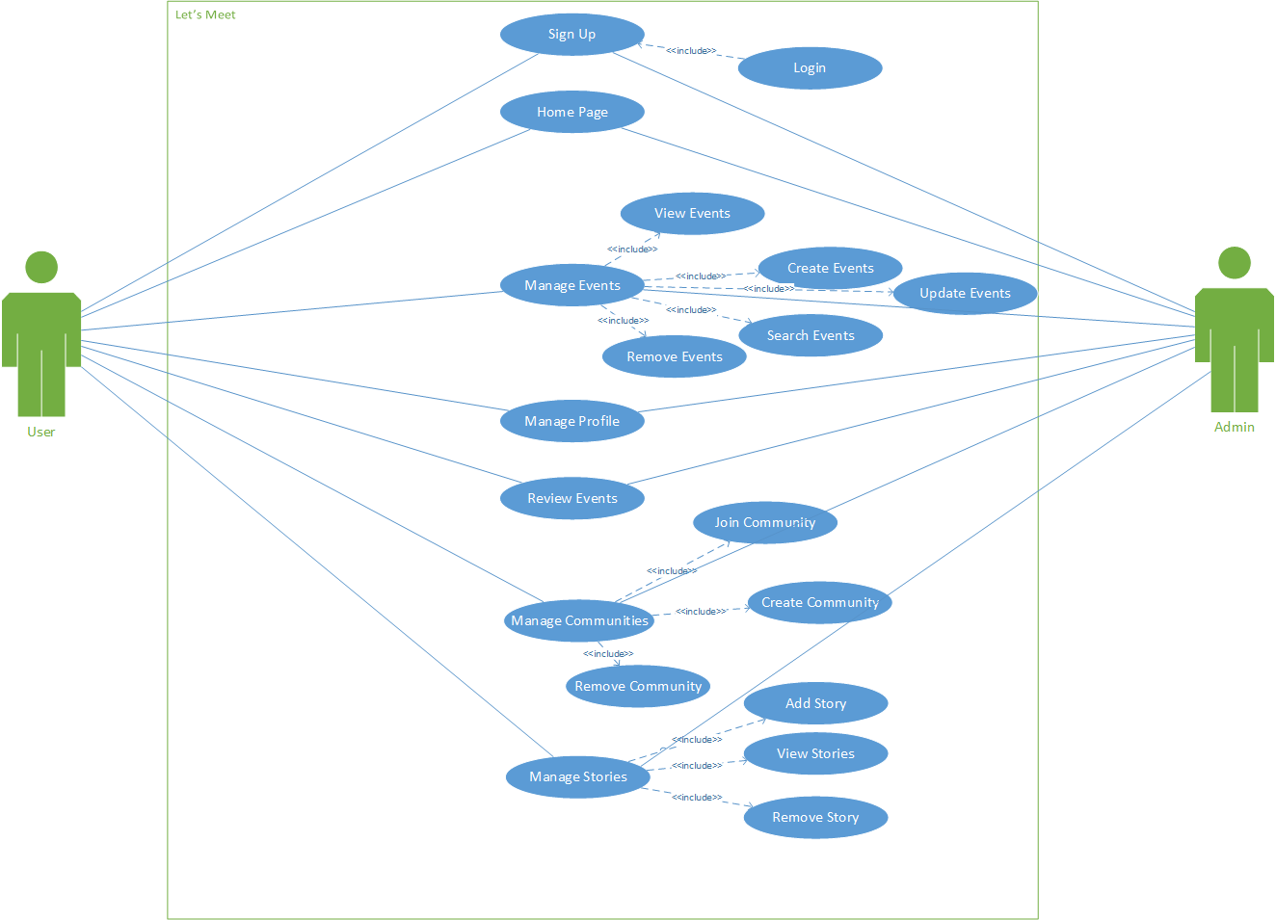

( fig 4.1 – Use Case of System)

# [4.4.2] Class Diagram

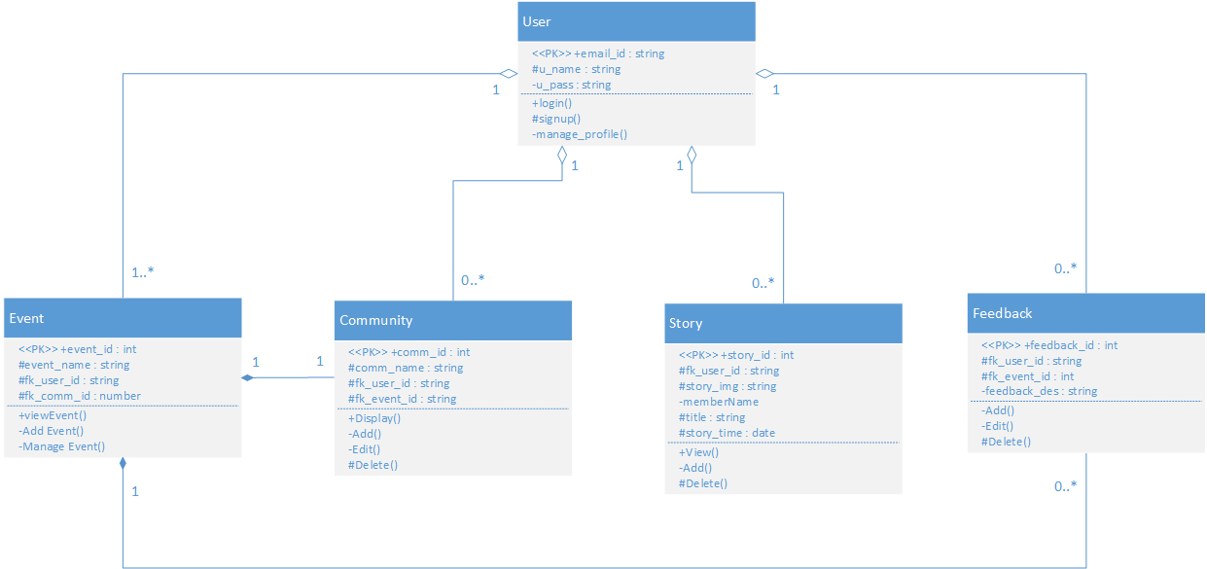

(fig 4.2 – Class Diagram)

# [4.4.3] Activity Diagram

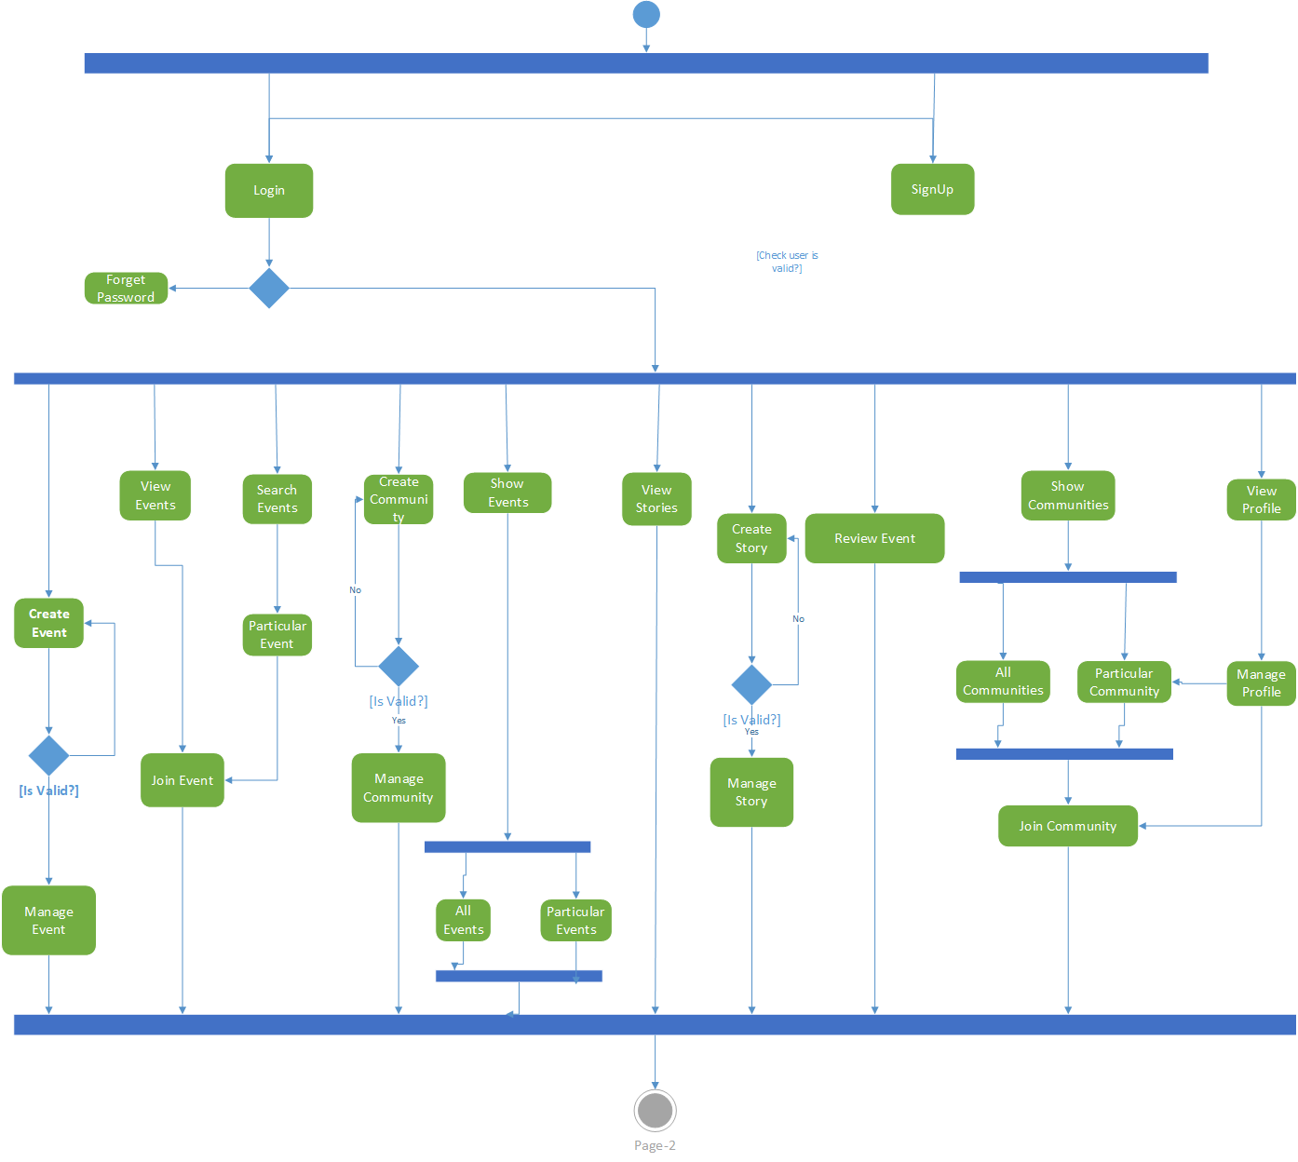

(fig 4.3 – Activity Diagram for User)

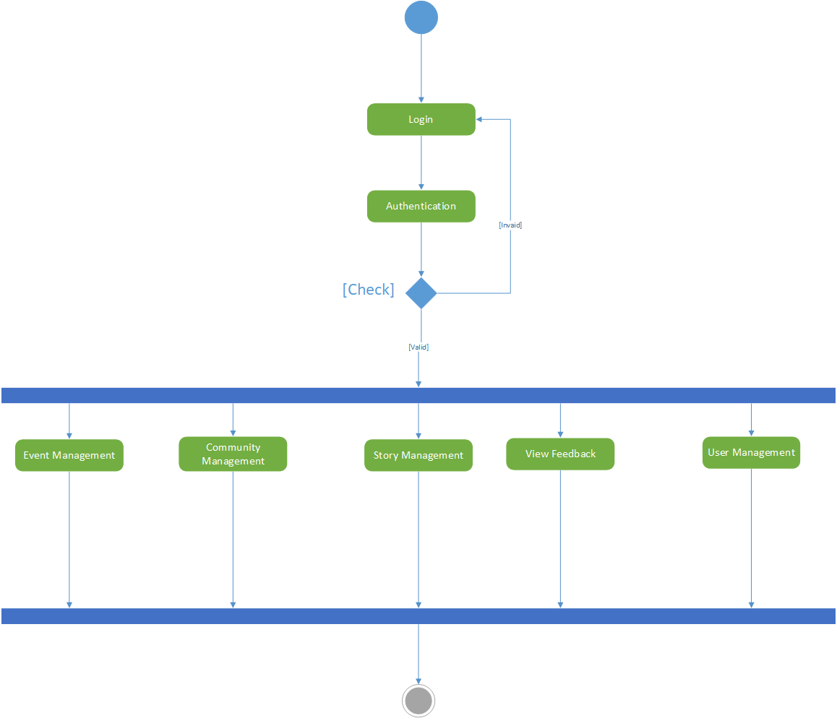

(Fig 4.4 – Activity Diagram for Admin)

# [4.4.4] Sequence Diagram

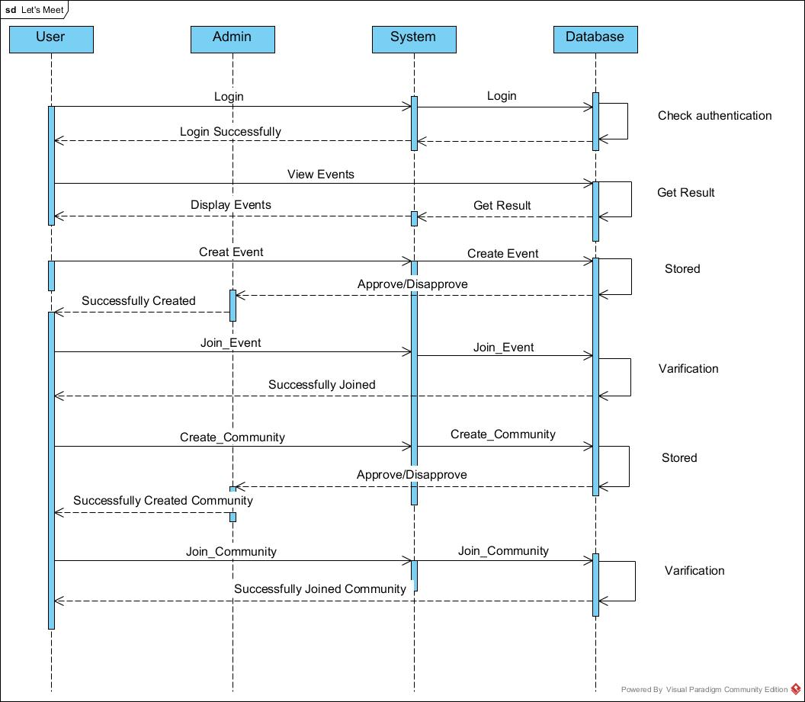

(Fig 4.5 – Sequence Diagram)

# 

(Fig 4.6 – Sequence Diagram)

# [**4.4.5**] Deployment Diagram

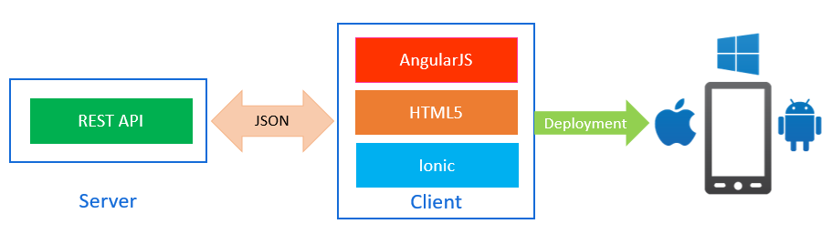

(Fig 4.7 – Deployment Diagram)

# [4.2] System Flow Diagram

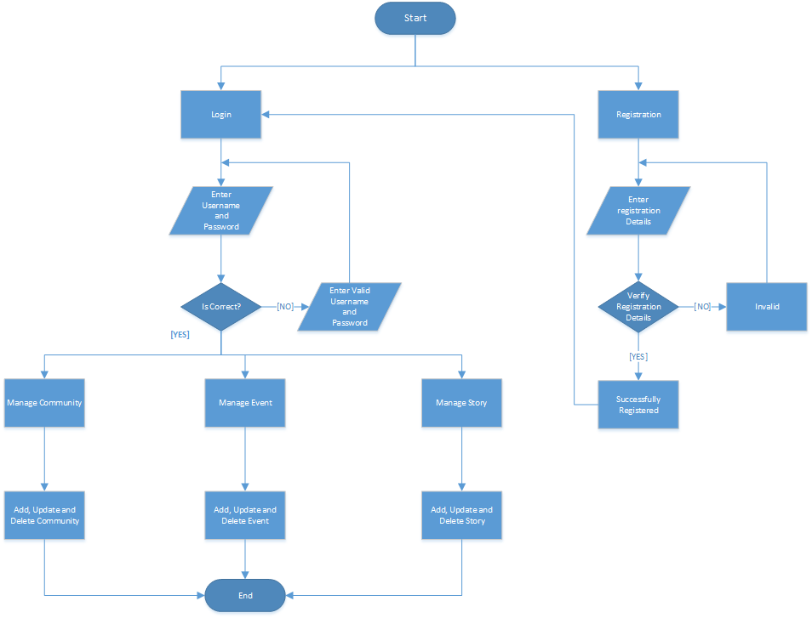

(Fig 4.8 – System Flow Diagram)

# [4.3] Data Dictionary

Users

|  |  |  |  |  |
| --- | --- | --- | --- | --- |
| Field | Data-Type | Constrains | Remarks | Description |
| User_id | Varchar(30) | Primary Key | - | User’s email id. |
| User_name | Varchar(20) | Not Null | - | Display User’s Name |
| User_photo | Varchar(500) | - | - | Display Picture |
| Gender | Boolean | - | - | User’s Gender |
| Password | Varchar(10) | Not Null | - | Password for Login |
| Mobile_no | Varchar(15) | - |  | User’s Mobile No |
| Birth_date | Date | - | - | User’s Birth Date |

Communities

|  |  |  |  |  |
| --- | --- | --- | --- | --- |
| Field | Data-Type | Constrains | Remarks | Description |
| Comm_id | Integer | Primary Key | Auto-Increment | Community id |
| Comm_name | Varchar(20) | Not Null | - | Community Name |
| Comm_des | Varchar(300) | Not Null | - | Describe the community |
| Comm_photo | Varchar(500) | - | - | Community Picture |
| Date | Date | Not Null | - | Date created |
| Created_by | Varchar(50) | Foreign Key | - | Users created Community |
| Comm_rating | Integer |  | - | Rating of Community |

Events

|  |  |  |  |  |
| --- | --- | --- | --- | --- |
| Field | Data-Type | Constrains | Remarks | Description |
| Event_id | Integer | Primary Key | Auto-Increment | Event’s Id |
| Event_name | Varchar(100) | Not Null | - | Event’s Name |
| Event_pic | Varchar(500) | - | - | Event Photo |
| Event_des | Varchar(500) | - | - | Event Description |
| Event_time | Varchar(20) | - | - | Event Time |
| Event_date | Date | Not Null | - | Event Date |
| Event_loc | Varchar(100) |  | - | Event Venue |
| Fk_user_id | Varchar(30) | Foreign Key | - | Who Created? |
| Fk_comm_id | Integer | Foreign Key | - | Under Which Community? |

Story

|  |  |  |  |  |
| --- | --- | --- | --- | --- |
| Field | Data-Type | Constrains | Remarks | Description |
| Story_id | Integer | Primary Key | Auto-Increment | Story id |
| Story_pic | Varchar(500) | Not Null | - | Story Photo |
| Fk_user_id | Varchar(30) | Foreign Key | - | Who Posted? |
| Story_title | Varchar(100) | Not Null | - | Story Caption |
| Story_time | Date | Not Null | - | When Story Posted? |

Community Members

|  |  |  |  |  |
| --- | --- | --- | --- | --- |
| Field | Data-Type | Constrains | Remarks | Description |
| Join_id | Integer | Primary Key | Auto-Increment | Community join Id |
| Fk_user_id | Varchar(30) | Foreign Key | - | User who joined community |
| Fk_comm_id | Integer | Foreign Key | - | Which community did user joined |

Feedbacks

|  |  |  |  |  |
| --- | --- | --- | --- | --- |
| Field | Data-Type | Constrains | Remarks | Description |
| Feed_id | Integer | Primary Key | Auto-Increment | Feedback id |
| Fk_event_id | Integer | Foreign Key | - | Under which Event |
| Fk_user_id | Varchar(30) | Foreign Key | - | Who gave feedback? |
| Feed_desc | Varchar(200) | Not Null | - | Feedback Description. |

Posts

|  |  |  |  |  |
| --- | --- | --- | --- | --- |
| Field | Data-Type | Constrains | Remarks | Description |
| Post_id | Integer | Primary Key | Auto-Increment | Post Id |
| Post_title | Varchar(30) | Not Null | - | Caption |
| Post_des | Varchar(200) | - | - | Describe the Post |
| Post_pic | Varchar(500) | - | - | Photo in Post |
| Fk_user_id | Varchar(30) | Foreign Key | - | User who posted this Post |
| Fk_comm_id | Integer | Foreign Key | - | Under which Community |
| Date | Date | Not Null | - | Date Created Post. |

Likes

|  |  |  |  |  |
| --- | --- | --- | --- | --- |
| Field | Data-Type | Constrains | Remarks | Description |
| Like_id | Integer | Primary Key | Auto-Increment | Like id |
| Fk_post_id | Integer | Foreign Key | - | Under which Post |
| Fk_user_id | Varchar(30) | Foreign Key | - | Who liked? |

|  |  |  |  |  |
| --- | --- | --- | --- | --- |
| Field | Data-Type | Constrains | Remarks | Description |
| Com_Id | Integer | Primary Key | Auto-Increment | Comment id |
| Fk_post_id | Integer | Foreign Key | - | Under which post |
| Fk_user_id | Varchar(30) | Foreign Key | - | Who commented? |
| Date | Date | Not Null | - | Date Created |
| Com_des | Varchar(300) | Not Null | - | Content of Comment |

Comments

RSVP

|  |  |  |  |  |
| --- | --- | --- | --- | --- |
| Field | Data-Type | Constrains | Remarks | Description |
| Rsvp_id | Integer | Primary Key | Auto-Increment | RSVP id |
| Fk_user_id | Varchar(30) | Foreign Key | - | Users attending event |
| Fk_event_id | Varchar(50) | Foreign Key | - | Which event user is going to attend? |

Polls

|  |  |  |  |  |
| --- | --- | --- | --- | --- |
| Field | Data-Type | Constrains | Remarks | Description |
| Poll_id | Integer | Primary Key | Auto-Increment | Poll Id |
| Poll_title | Varchar(100) | Not Null | - | Tag line of Poll |
| Option1 | Varchar(50) | Not Null | - | First opinion of poll |
| Option2 | Varchar(50) | Not Null | - | Second opinion of Poll |
| Option3 | Varchar(50) | - | - | Third opinion of Poll |
| Option4 | Varchar(50) | - | - | Fourth opinion of Poll |
| Fk_user_id | Varchar(30) | Not Null | - | Who Created? |
| Fk_comm_id | Integer | Not Null | - | Under Which Community? |

Follower

|  |  |  |  |  |
| --- | --- | --- | --- | --- |
| Field | Data-Type | Constrains | Remarks | Description |
| Follo_id | Integer | Primary Key | Auto-Increment | Follower Id |
| Fk_user_id | Varchar(30) | Foreign Key | - | User being followed |
| Fk_us_id | Varchar(30) | Foreign Key | - | Who Followed? |

Categories

|  |  |  |  |  |
| --- | --- | --- | --- | --- |
| Field | Data-Type | Constrains | Remarks | Description |
| Cat_id | Integer | Primary Key | Auto-Increment | Category Id |
| Cat_name | Varchar(20) | Not Null | - | Category Name |

# [4.4] User Interface

Tutorial

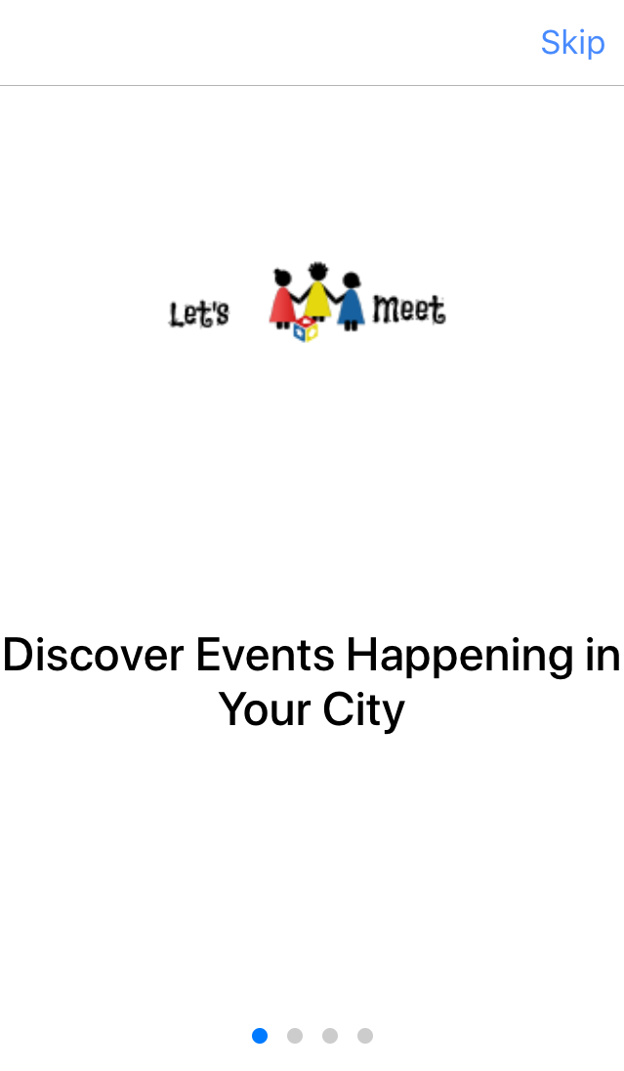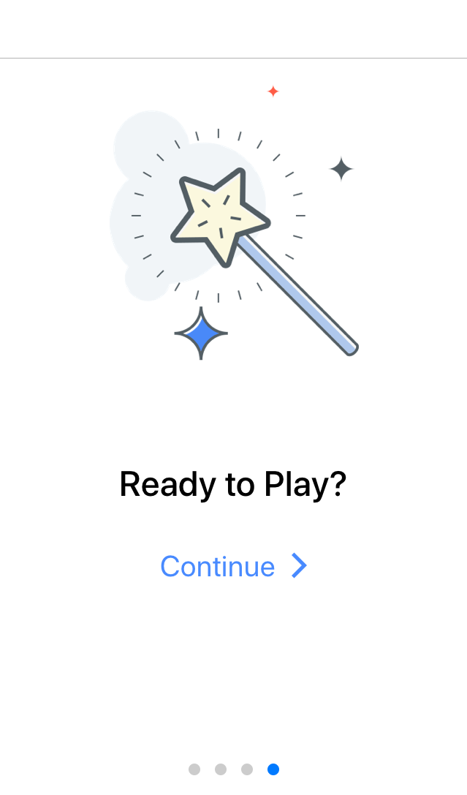

Start-up

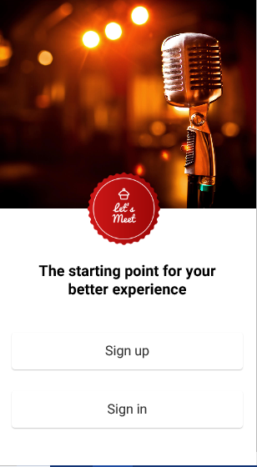

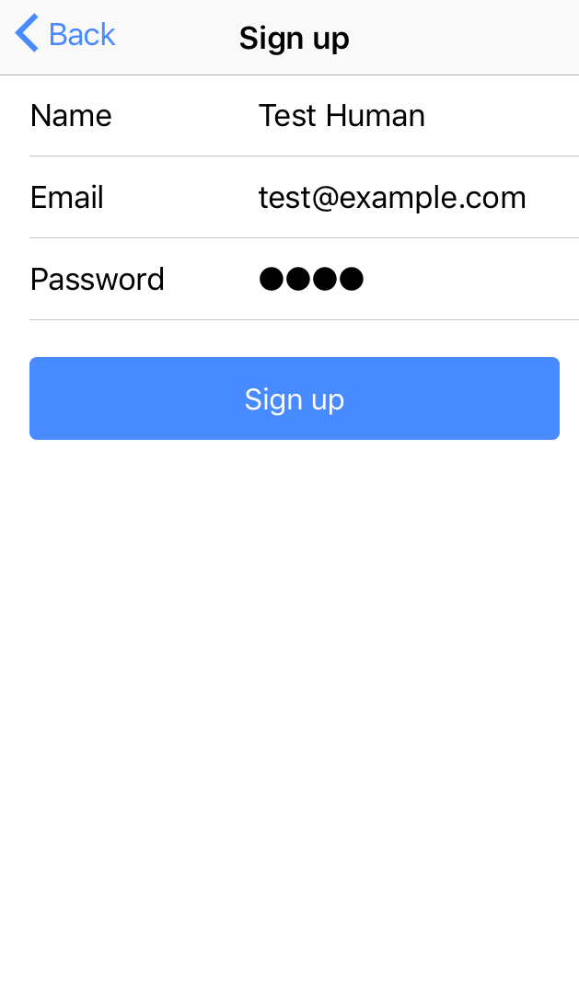Sign Up Page

Sign In Page

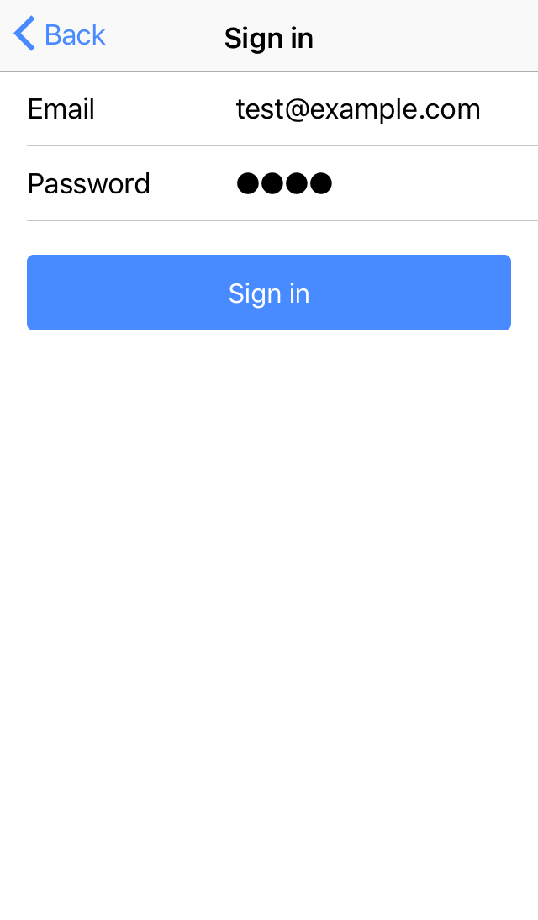

View Events Tab

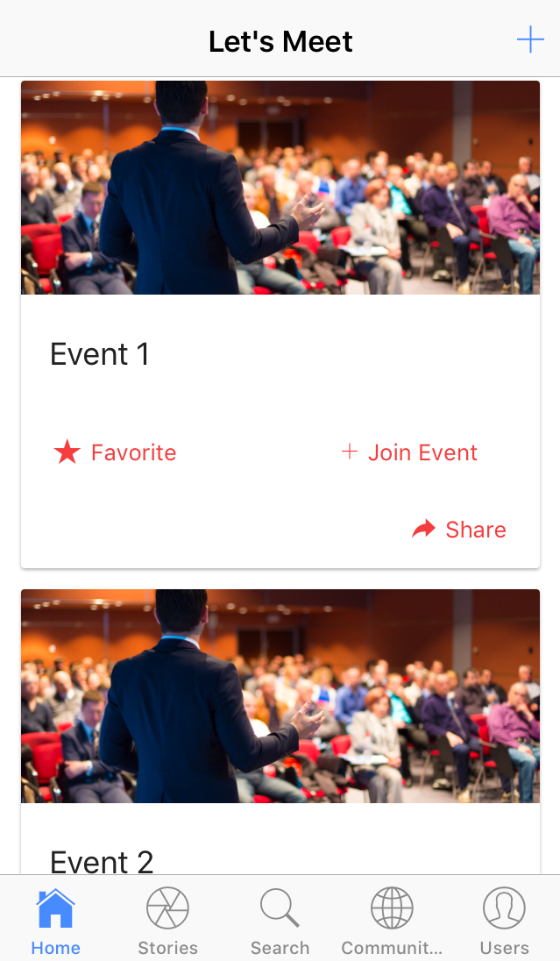

Create Event Page

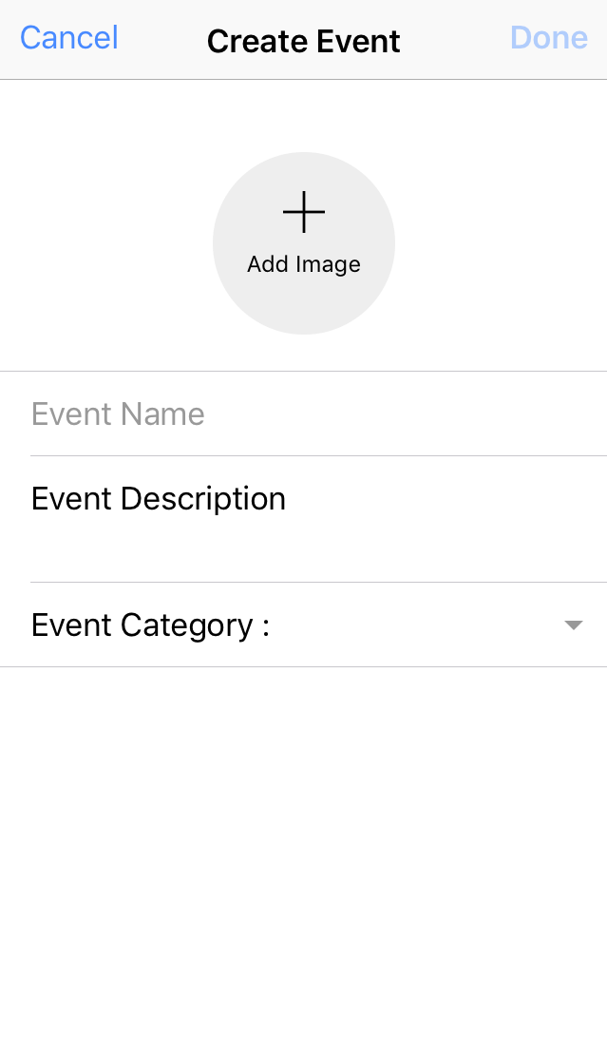

View Stories Tab

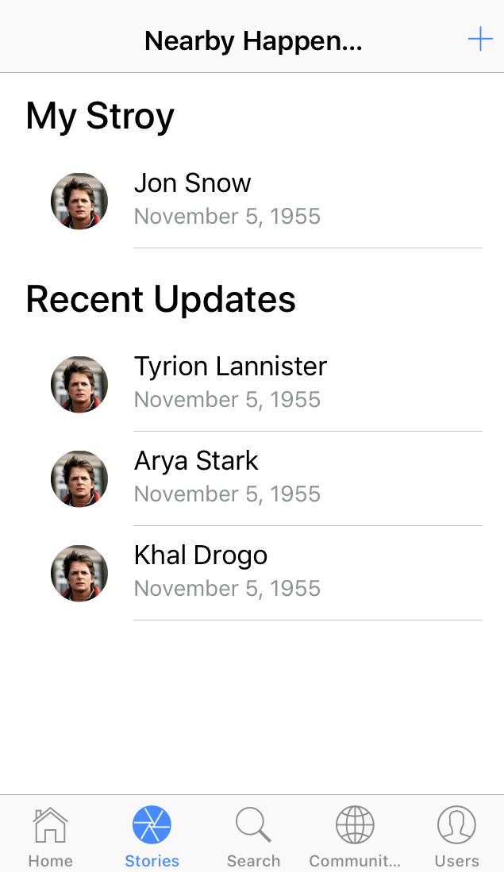

Add Story Page

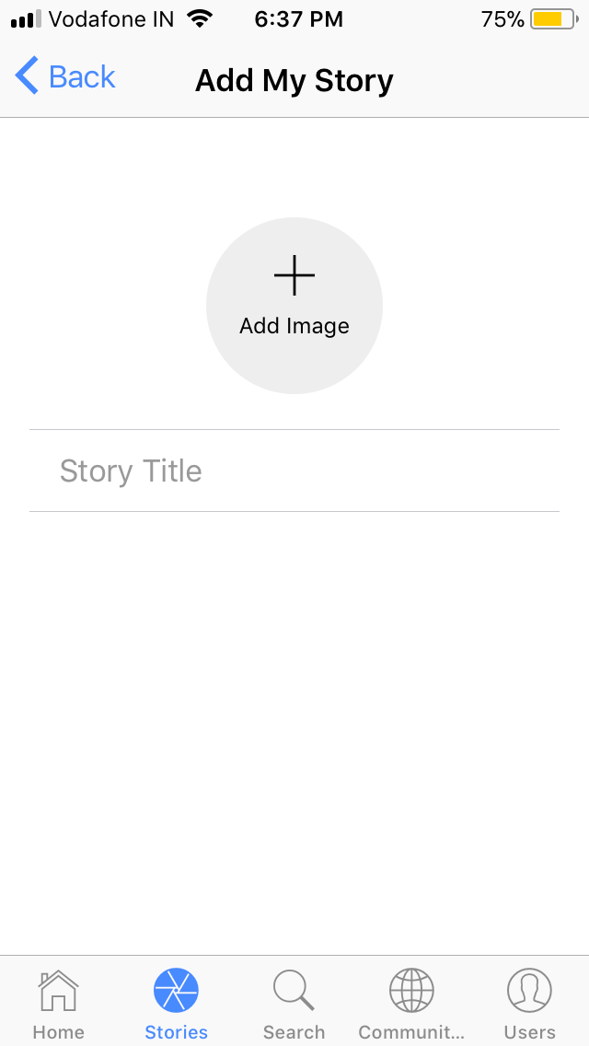

Search Tab

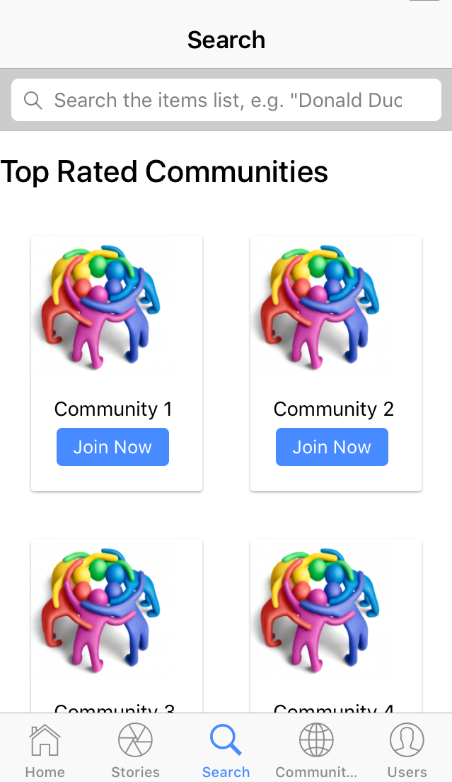

Communities Tab

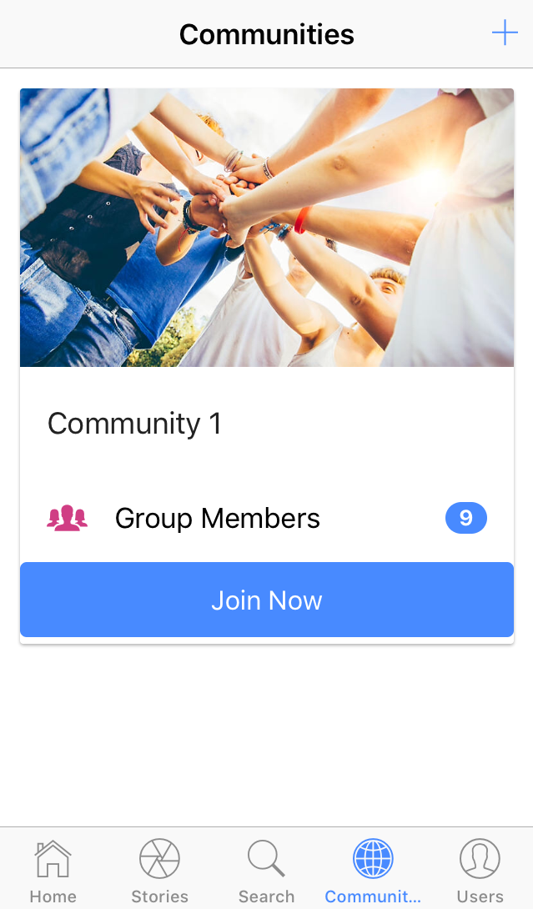

Create Community Page

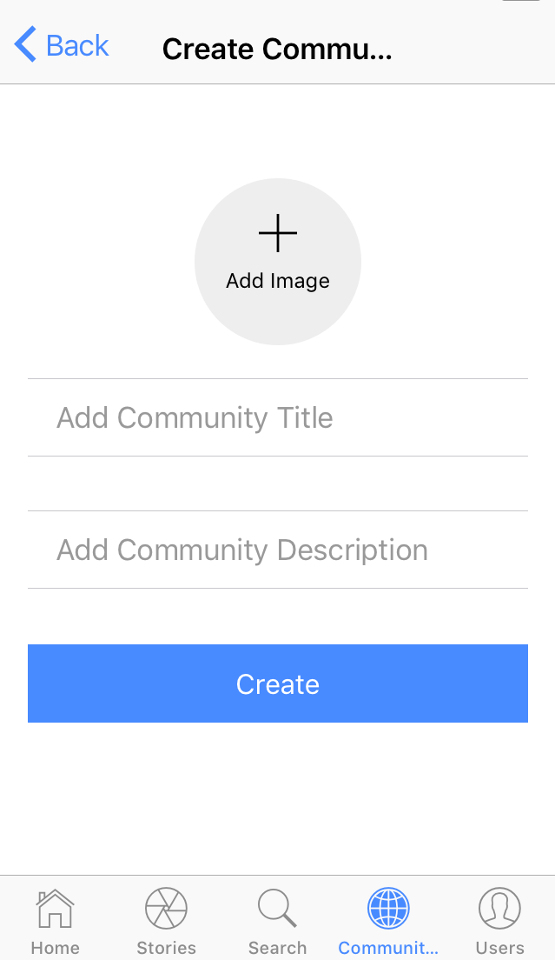

User Profile Tab (Events)

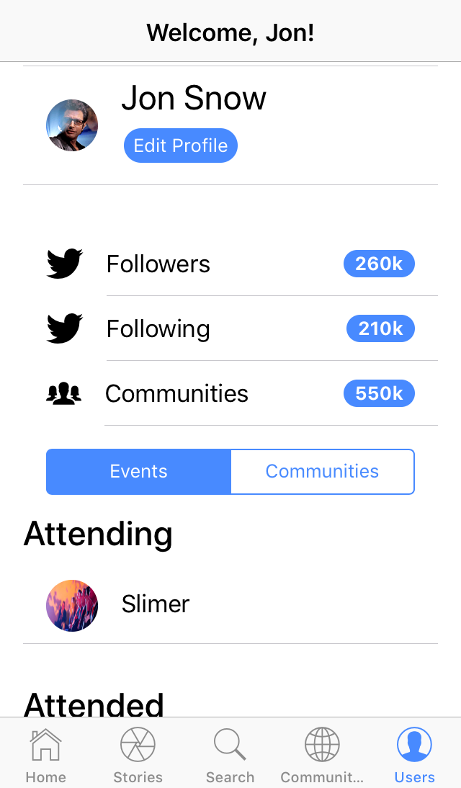 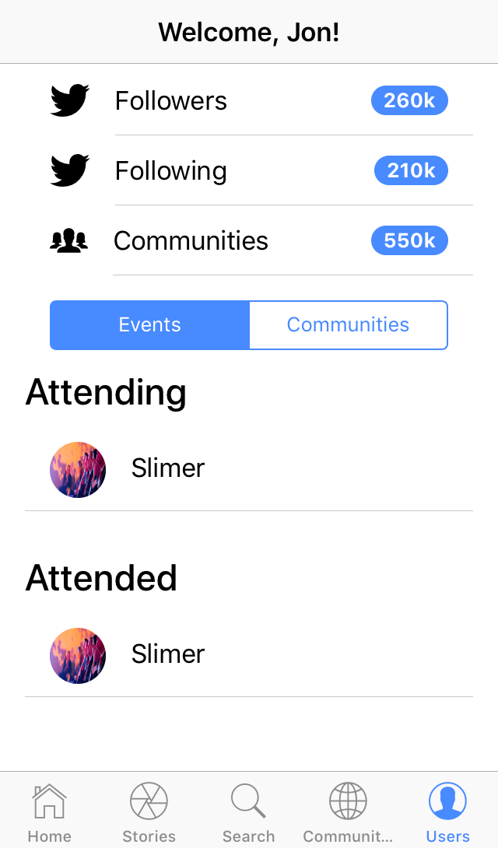

User Profile Tab (Communities)

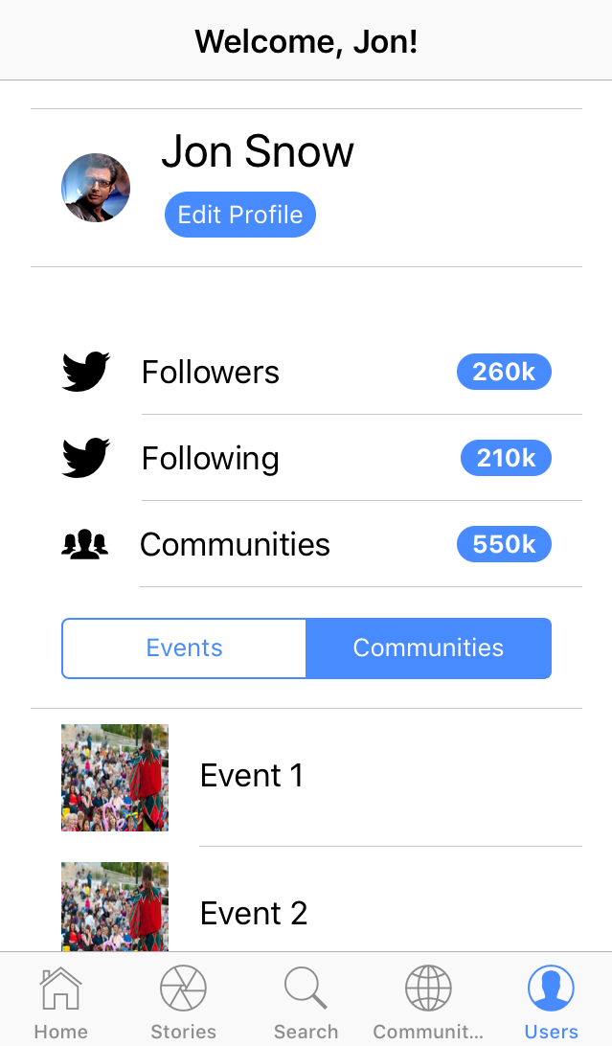

# [**4.5**] System Navigation

# [**5.1**] Assumptions

* The users should have internet connection.
* The users should know the English language, as the interface will be provided in English.
* It is assumed that the service is available 24x7.
* One should remember his ID and password.
* He/she is having knowledge about what is community.

# [5.2] Limitations

* If user upload/share his very important document then there is no provision for security.
* If the user might not able to deal with English language then user might not able to use the system efficiently.
* User must be a member of any community to create event.

# [5.3] Conclusion

Main concern for developing this system was to aware normal people like us about the new concepts like community. MNC like TCS are using this kind of system for better communication between their employees. But most of us are not aware about this. It is useful in each every field whether it is IT field or NON-IT field. Students like us can have communities so that we can also share our new ideas/videos/images with each other so fast and so easily.

We know we might have made some mistakes knowingly or unknowingly. But all the suggestions regarding to this system are always welcome.

# [5.4] Future Scope

* There are chances that system can cooperate with payment gateways to generate revenue.
* There are chances that user can register in event directly through our system.
* There are chances that users can directly communicate with each other and as well as with speakers through our system.

# Bibliography

* SOFTWARE ENGINEERING a practitioner’s Approach Seventh Edition by Roger S. Pressman
* <https://angular.io/>
* <https://ionicframework.com/>